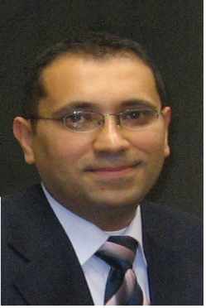
Dr. Mahmoud TURABI
New Technology laws

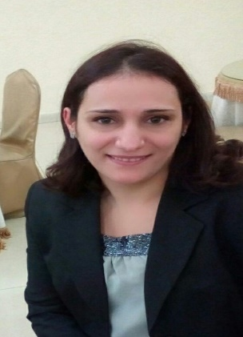
Dr. Randa HENDAWI
Arbitration

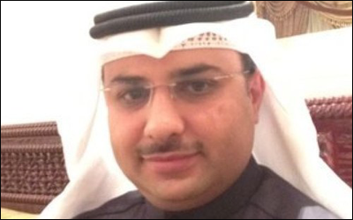

Dr. Abdussalam ALANZI
International Commerce

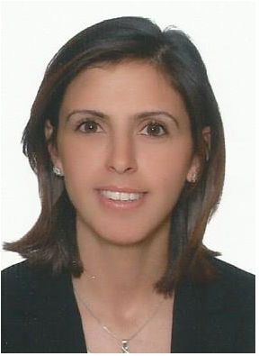
L. Lubna ZUABI
Intellectual Property


Dr. Omar AAMR
International public law

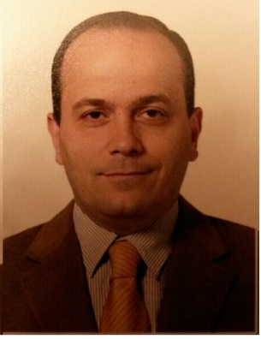
Dr. Fadi ACHI
Commerce and Finance


Johnny Nassar
Computer science Engineer

